Difference between DELETE, DROP and TRUNCATE

**1. DELETE :**  
Basically, it is a [Data Manipulation Language Command (DML)](https://www.geeksforgeeks.org/sql-ddl-dql-dml-dcl-tcl-commands/). It is use to delete the one or more tuples of a table. With the help of “DELETE” command we can either delete all the rows in one go or can delete row one by one. i.e., we can use it as per the requirement or the condition using Where clause. It is comparatively slower than TRUNCATE cmd.

* **SYNTAX –**  
  If we want to delete all the rows of the table:

DELETE from ;

* **SYNTAX –**  
  If we want to delete the row of the table as per the condition then we use WHERE clause,

DELETE from WHERE ;

**Note –**  
Here we can use the “ROLLBACK” command to restore the tuple.

**2. DROP :**  
It is a Data Definition Language Command (DDL). It is use to drop the whole table. With the help of “DROP” command we can drop (delete) the whole structure in one go i.e. it removes the named elements of the schema. By using this command the existence of the whole table is finished or say lost.

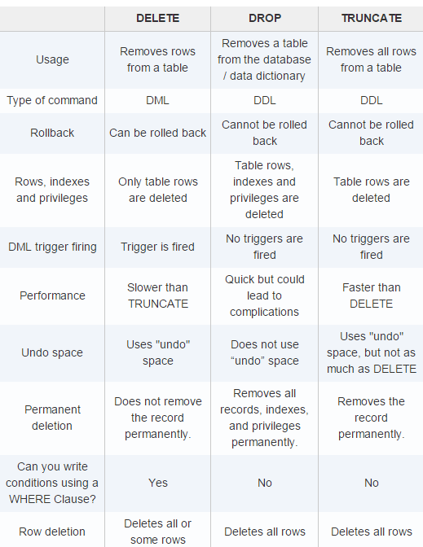

CREATE TABLE Persons1 (  
    ID int NOT NULL,  
    LastName varchar(255) NOT NULL,  
    FirstName varchar(255),  
    Age int,  
    CONSTRAINT PK_Person PRIMARY KEY (ID,LastName)  
);

CREATE TABLE Persons (  
    ID int NOT NULL,  
    LastName varchar(255) NOT NULL,  
    FirstName varchar(255),  
    Age int,  
    PRIMARY KEY (ID)  
);

ALTER TABLE students  
ADD CONSTRAINT PK_Student PRIMARY KEY (Roll_No);

ALTER TABLE Persons  
DROP PRIMARY KEY;

CREATE TABLE Orders (  
    OrderID int NOT NULL,  
    OrderNumber int NOT NULL,  
    PersonID int,  
    PRIMARY KEY (OrderID),  
    FOREIGN KEY (PersonID) REFERENCES Persons(ID)  
);

ALTER TABLE Orders  
ADD FOREIGN KEY (PersonID) REFERENCES Persons(PersonID);

ALTER TABLE Orders  
DROP FOREIGN KEY FK_PersonOrder;